1.1) The founding team of PandoLogic is: Motti Mor,Avi Balali, Gal Almog.

Today Motti Mor is Chief Operations Officer and General Manager at PandoLogic,

Avi Balali is Senior Vice President of Engineering & Development at PandoLogic,

Gal almog is CEO at Talenya.

1.2) If my phone stopped ringing the first thing I would try to do is to restart my phone.

If that won’t solve the problem, I will try to search in the settings app for settings that may have cause this. if this won’t work , I will try to check if there's a software update that could solve the problem. If this won’t work, I will try to scan my phone with an anti-virus app in search for viruses and in the meantime uninstall any suspicious apps. If that won’t solve it, I will put my phone in the lab for repair.

1. A full cycle of the clock there is 12 hours, which means that every hour, the hour hand moves at (360/12 =)30 degrees. When the time is 15:00 the hour hand will point at the number 3. After 15 min, the hour hand will move (15/60 = )¼ of the way towards the number 4. This means after 15 minutes the hour hand will move (30*1/4) = 7.5 degrees from the number 3, exactly where the minute hand will be at 15:15.
   1. I’ve chosen to sort the campaigns by their total cost in order to better understand which campaign invests more money in comparison to the others.

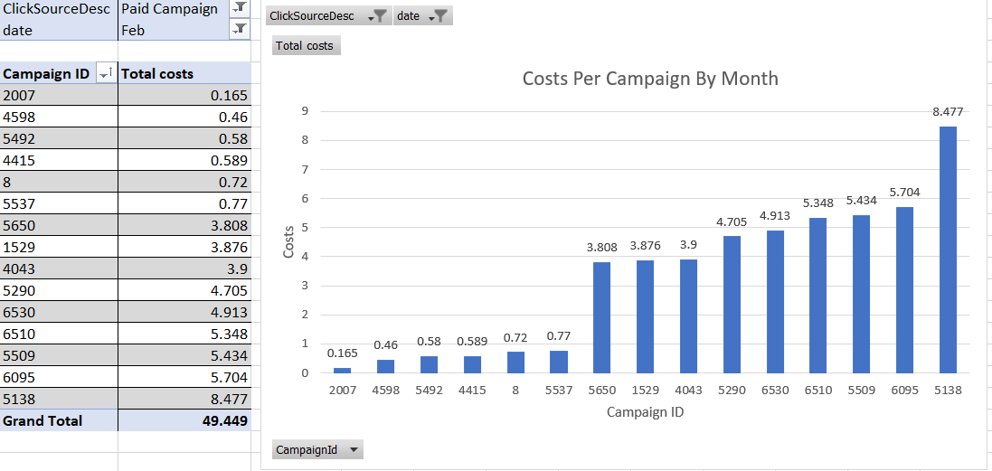

* 1. You can see the column on the attached excel file.

I’ve used this function: =VLOOKUP([@JobID], Table2[#All], 2, FALSE).

* 1. In the following chart we can see the performance of every job title in the system. We can understand which job is more popular and which job will cost more in comparison to other jobs.

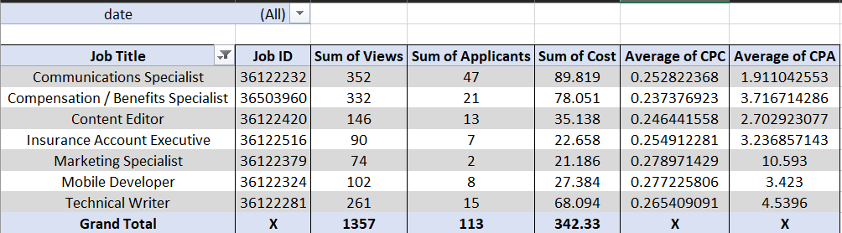

* 1. In my opinion RPM Master Affiliate has the best performance.

It’s easy to think that ZipRecruiter or LinkedIn has the best performance because of their number of views but if we take a look at the “CVR by Affiliate” chart we notice that RPM and AL.com have far better conversion rates than the other affiliates. Even though that AL.com has the greatest CVR rate it has a very small number of views and applicants which are less useful. On the other hand, RPM has a large number of views, the most Applicants of them all and is priced reasonably well.

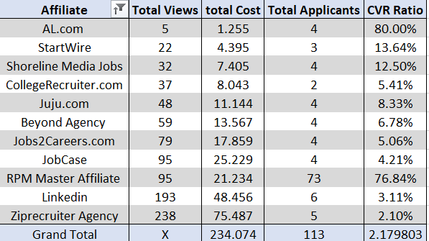

2.5) When there is a lot of data, it’s much harder to decide which location to choose and the decision will depend on the client’s needs. The client’s main goal is to get a CVR that’s as high as possible, although high CVR doesn’t necessarily mean the best results (as we can see in the last question). If the CVR is high but the views and the applicants are low like at El Sobrante, CA it indicates that there is a good match of the target audience but the location may be with relatively low population. If a small company were my client, I would suggest a location like San Pablo, CA, because this location has the highest CVR, but has relatively low visits, meaning not a lot of applicants but enough to find a match. If a company with a large budget were my client, I would suggest a location like Newark, CA or Richmond, CA. It will be pricier, but there will be way more relevant applicants, and much more traffic.

From another angle lots of views can say two things about your ad: the first is that you designed it well enough to make customers click on the ad. The second is to make the ads fit a lot of people, in order to make enter the ads. In this case you must have a high CVR in order to pay for the clicks.

I will not recommend using Millbrae,CA location and that’s because out of all the locations, it has 0 applicants and at the same time has the most views, which means that the company will pay money but won’t get any applicants in return.

2.6) According to the chart we can see that company D has the best views to applicants' conversion ratio.

|  |  |  |  |
| --- | --- | --- | --- |
| **Company** | **Total Views** | **Total Applicants** | **Average of CVR** |
| C | 15751 | 98 | 0.7497754% |
| A | 11215 | 167 | 1.2787317% |
| B | 13666 | 258 | 1.3996982% |
| D | 40504 | 660 | 1.5229793% |
| **Grand Total** | **81136** | **1183** | **1.3014400%** |

2.7) According to the chart we can see that company D has the best applicants per job Ratio

|  |  |  |  |
| --- | --- | --- | --- |
| **Company** | **Applicants** | **Number Of Jobs** | **Average Applicants Per Job** |
| C | 98 | 1457 | 6.7261496% |
| A | 167 | 1474 | 11.3297151% |
| B | 258 | 1324 | 19.4864048% |
| D | 660 | 3192 | 20.6766917% |
| **Grand Total** | **1183** | **7447** | **15.8855915%** |